1. Measures of Dispersion (ctd.)

Reading: pp. 114–16

Homework Problem (due Monday): In a study to determine their tensile strength, bolts were tested until failure in an impact environment. The amount of energy (in foot-pounds) absorbed by each of 18 bolts is supplied in the Excel spreadsheet, bolts.xls (on class webpage).

Download the data and calculate:

(a) variance and standard deviation treating the data as a population.
(b) variance and standard deviation treating the data as a sample.

2. Probability Theory

Characteristics of 'Probability'

- A theoretical construct
- A belief
- Indicates 'likelihood of occurrence'
- Ranges from 0 to 1: 0 = completely impossible, 1 = completely certain

Two Different Interpretations of Probability

Classical or theoretical interpretation: A probability is the number of outcomes of interest divided by the total number of possible outcomes.

Example: What is the probability of rolling a '6' with a fair die?

Number of outcomes of interest: 1 (a '6'')
Number of possible outcomes: 6 ('1', '2', 3', '4', '5', '6')
Probability = 1 / 6 = 0.167.

Expected relative frequency (or long run average) interpretation. A probability is the expected proportion of times an event of interest would occur given an infinite number of opportunities.

Example: What is the probability of rolling a '6' with a fair die?

Roll a fair die many times.
As the number of rolls increases, the relative proportion of times that
'6' occurs will approach 0.167.

Notation and Definitions

A, B, etc. | some possible event (e.g., flipping a 'heads')
P(A) | the probability that A actually occurs
~A | the event of A not happening. Example: if A means flipping a 'heads', then ~A means flipping a 'tails'
joint event | an event defined by two elementary events
P(A and B) | probability of both A and B occurring
P(A or B) | probability of either A or B (or both) occurring
P(B|A) | the conditional probability of B occurring given that A has occurred. Example: the probability that it will rain tomorrow given that it is raining today.
P(X = x) | the probability that a random variable, X, will be observed to have a specific value, x.

Rules of Probability

- Complementarity: P(~A) = 1 – P(A)

Addition Rules

- General: P(A or B) = P(A) + P(B) – P(A and B) (Example: winning two separate lotteries)
- Mutually exclusive events: P(A or B) = P(A) + P(B) (Example: rolling a '6' or a '5' on a die)
- Mutually exclusive and exhaustive events: P(A or B) = 1

The conditional probability of B given A is



Two events are independent if the occurrence of one event in no way affects the probability of the second event.

- Multiplication rule for independent events: P(A and B) = P(A) × P(B)

- Multiplication rule for dependent events: P(A and B) = P(A) × P(B|A)

Reading: pp. 135–143

Homework Problem 2 (due Monday): A deck of playing cards has four suits (spades, hearts, diamonds, clubs) of 13 cards each. Two suits are black (spades & clubs) and two are red (hearts & diamonds). Each suit has three face cards (1 king, 1 queen, and 1 jack). What is the probability that a card drawn at random from a deck of playing cards will be:

(a) a heart;

(b) a red card;

(c) a face card;

(d) a black face card?

Show your work (i.e., fractions or operations involved in computation of answer).

3. Binomial Probabilities

Bernoulli process. A sequence of 'trials' in which: (1) each trial has only two possible outcomes ('success' or 'failure'); (2) the probabilities of success/failure are constant across trials; and (3) trials are statistically independent of each other. (Example: repeatedly flipping a coin and observing 'heads' or 'tails'.)

Formula for a binomial probability:

P(exactly k successes out of n trials) = P(n, k)

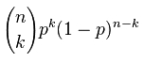
where p is the probability of success in a single trial.

Binomial coefficient is calculated from factorials:

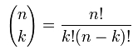

Alternative notation for binomial coefficient:

_{n}C_{k} = number of combinations of n things taken k at a time

Example: What is the probability of getting exactly two heads out of three coin flips?

Ways to Get Three Heads | Probability
H H T | .5 × .5 × .5 = .125
H T H | .5 × .5 × .5 = .125
T H H | .5 × .5 × .5 = .125
Net Probability | .125 + .125 + .125 = .375

Check
(1) probability of 'heads' in one flip: p = .5
(2) probability of some specific sequence with exactly two heads:
p² (1 – p)¹ = .25 × .5 = .125 (multiplication rule for independent events)
(3) number of ways to get exactly two heads in three flips:
3! / (2! 1!) = 3
(4) probability of any sequence with exactly two heads:
3 × .125 = .375

Cumulative binomial probability = the probability of observing k or fewer successes out of n trials.

4. Pascal's Triangle

Pascal's (1623–1662) triangle is a simple method to compute the binomial coefficient, i.e., an alternative to the formula:

How it works: coefficients in lower rows are produced by adding two adjacent coefficients in the row above:

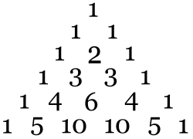 | 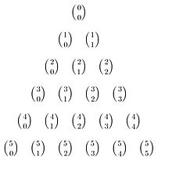

1. For each row, first and last value is always 1.

2. (Therefore), first two rows contain all 1's.

3. Starting with third row, a value is produced by adding the two numbers from the line above to its left and right.
4. Example, in row 3, the "2" is produced by adding 1 (above it left) and 1 (above it right).

5. Binomial Probabilities in Excel

BDISTPROB(k, n, p, cumul)
cumul = 0 (regular binomial probability)
cumul = 1 (cumulative probability)

Gives the probability (noncumulative or cumulative) of exactly k successes out of n trials, where the probability of a success in a single trial is p.

COMBIN (n, k) - Gives number of combinations of n things taken k at a time

Computational shortcuts

- for symmetrical distributions (P = .5), P(n, k) = P(n, n – k); so compute for n or n – k, whichever is smaller (Example: probability of exactly 98 heads out of 100 coin clips = probability of exactly 2 heads.)
- cumulative distributions can be produced forwards (starting with 0 and adding), or backwards (starting with 1 and subtracting). When k > n/2, some people do the latter.

Binomial distribution: the set of probabilities for all possible numbers of successes (k = 1, ..., n) out of n trials.
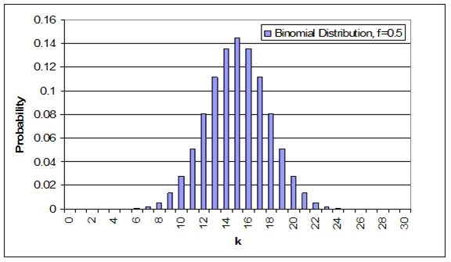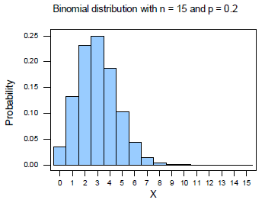

Symmetric (p = .5) Asymmetric (p ≠ .5)

Expected Value of a Binomial Distribution

Standard Deviation of a Binomial Distribution

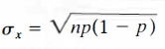

Reading: 150–156,

Homework Problem 3 (due Monday)

(a) Use Excel to produce a complete binomial distribution for observing from 0 to 10 heads out of 10 coin flips.

The coin is fair (unbiased), i.e.., P(heads) = P(tails) = .5

Supply results using this template, filling all indicated columns/cells:

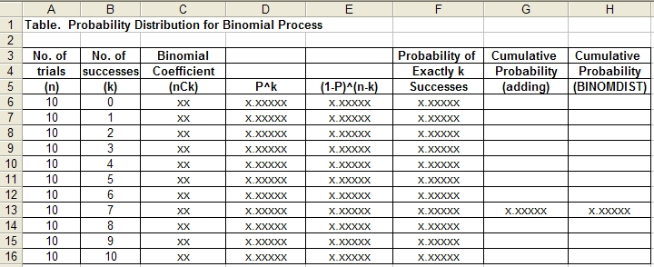

(b) Calculate the cumulative probability of 7 or fewer heads. Do this two ways: by adding appropriate entries from Column F, and by using the BINOMDIST function with the cumul=1 option. Place results where indicated above in Columns G and H.

(c) produce a histogram to show the probability distribution:
- x-axis label: Number of Heads
- y-axis label: Probability
- Title: Probability Distribution for Number of Heads Observed for Ten Coin Flips
- Omit table legend and gridlines.

